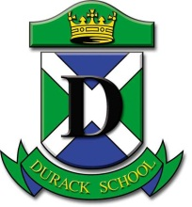 | DURACK SCHOOL  50 Woodlake Boulevard Durack NT 0830  PO Box 225 Palmerston NT 0831  Phone ~ 08 8935 9259 Fax ~ 08 8935 9260  Email: durack.school@ntschools.net Website: http://durackschool.nt.edu.au

17 November 2016

Dear Parents/Caregivers

Along with the other Primary Years classes, 5/6 Walsh is performing at the Primary Years Awards Assembly at Durack School on Tuesday 13th December.

This year they are performing a zombie dance. Please help us to costume your child by providing appropriate clothing for this theme. Op Shops are a great place to buy cheap clothing that can be “zombiefied”, ie ripped and dirty. Alternatively your child may have some old clothing that is nearing it’s used by date. Zombie make-up is to be kept to a minimum and definitely no fake blood – we don’t want to scare the little kids.

Can you please ensure that your child brings the required costume items (labelled with full name) to school prior to Wednesday 7th December as we will be having a dress rehearsal.

If your child is not able to participate at the Awards Assembly or will be absent, please let me and/or their classroom teacher know as soon as possible as this may impact on the performance.

I hope you will be able to attend, as the children are looking forward to their performance.

If you have any questions or queries regarding this performance or any difficulties costuming your child, please do not hesitate to contact me on the number above or via email.

Kind regards
Jennifer Walker
Jennifer Walker
Performing Arts Teacher

jennifer.walker@ntschools.net

