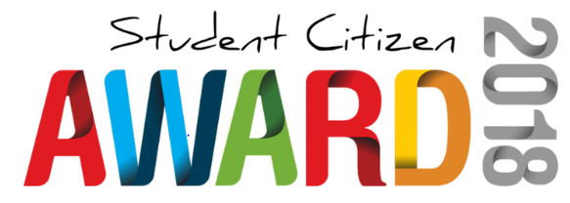
Students are invited to nominate for the:
Australia Day Council – Student Citizen Award 2018
- Students must write their own application, but parents may support as required.
- Please provide evidence for as many of the following criteria as you can.
- Applications close Thursday 28th September at 9am
Student Name: | Class:

- Sense of Fair Play

- Generosity of Spirit

- Concern for Others

- Cultural Understanding

- Positive Attitude & Involvement

